

Dr. Susan, Morales inc.
2022-09-09
Dr. Morales
Unit 7795 Box 9991, DPO AE 03550
Phone: 5616801208
Fax: 8865139307

Re: Jaclyn, Young
PHN: 9769131960
Birthdate: 01-Nov-1964
Address: 76109 Steven Streets Apt. 652, Jennifermouth, RI 07621
Patient number: 4376813125

To Whom It May Concern:

This is a medical letter to state the above patient is pregnant with expected delivery date of 07-Aug-2025. Hoping this information is satisfactory for your requirements.

Thank you.

Sincerely,
Dr. Susan, Morales
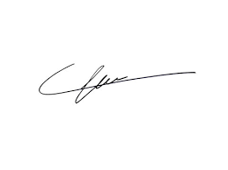
FRCS© NCMP
Clinical Assistant Professor, UBC
Department of Obstetrics and Gynecology SMH

